Transfer Credit, Including Credit by Examination
Students must submit official records directly from the source institution for all transfer courses, including credit by examination reports. Upon receipt of these records the Registrar’s Office will evaluate the transcripts according to the general policies of the University and subject to the review of the appropriate academic department. A Transfer Evaluation Report (TER) provides students with an official record of how their credits transferred to Saginaw Valley.
- The University will review unofficial or incomplete transcripts to assist students at the time of their initial enrollment, but all students must submit official records from the source institution in order to receive credit. Students who do not provide official final records will not be fully admitted to SVSU and are prohibited from further enrollment until these records are received.
- The minimum acceptable grade for transfer credits is a “C-“. Courses with a grade below “C-” are not transferable.
- Appeals of transfer credit evaluations must be made in writing to the Associate Registrar and should include appropriate supporting materials (i.e. course descriptions, syllabi, etc).
- All Advanced Placement (AP) credits require a minimum score of “3” or “4” in order to receive credit at Saginaw Valley, depending on the test. Scores for other forms of credit by exam may vary depending on the testing source.
- Remedial courses do not transfer to Saginaw Valley, but equivalencies of these courses are recognized for completing Basic Skill requirements and in meeting course prerequisites.

Transfer Credit Limitations
The following limitations apply to all sources of transfer credit:
- The maximum number of credits accepted from all sources is 93 credits.
- The maximum number of credits accepted from all two-year institutions is 62 credits.
- For students whose total transfer credits exceed the above mentioned limitations, the University will transfer the maximum acceptable number of credits that best apply toward a specific major or academic program.
- Transfer credits are not included when computing the SVSU GPA. Grades received from transfer credits are not included in the SVSU GPA, but these grades may be referenced by individual academic departments when granting admission to their respective programs.

ADVISING TIP: PROCRASTINATION = BLOCKED
Students with incomplete or unofficial records are prohibited or “blocked” from registration if their official records have not been received by the university. You will not be able to register beyond your first semester so make sure your records have been sent and received by Saginaw Valley. Don’t delay this process!!

Sample Transfer Equivalency Report

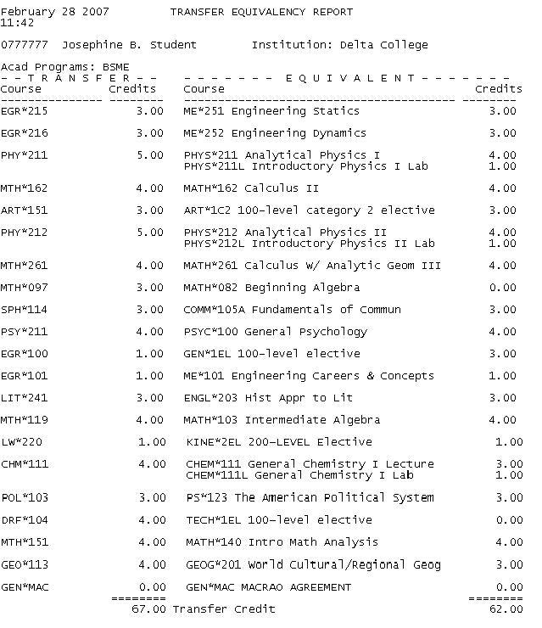
…this is how they transfer to SVSU

These are the courses completed at the original transfer institution…
This course does not have a direct equivalent at SVSU, but the “1C2” means it will count as a General Education Category 2 Art course.

Remedial courses do not transfer credits to SVSU, but they will apply toward the completion of basic skills requirements.

Because this course does not have a specific equivalent at SVSU, it has transferred as a general elective.

This student was awarded the MACRAO/MTA stamp by her transfer
institution and may qualify for General Education waivers.

Total credits completed at transfer institution
Total credits transferred to SVSU

